**Reco Project Report – Sprint 1**

**Group Members:**

|  |  |
| --- | --- |
| Mehmet Yaramancı (SCRUM Master) |  |
| Metali Tekiz (Product Owner) |  |
| İbrahim Dokuzer  Onur Öneş |  |

**Description:**

Reco is a web service which filters, corrects and makes recommendations whenever a probable incorrectly spelled (meaningless) word given by the user. (like a Google search expression recommendation).

**Product Backlog:**

|  |  |  |  |  |
| --- | --- | --- | --- | --- |
| **ID** | **Story** | **Priority** | **Time Estimation** | **Status** |
| 1 | WebService ve Web Interface | 1 | 16h | Completed |
| 2 | Dictionary creation | 1 | 8h | Not started |
| 3 | Adminstrator interface | 3 | 12h | Not started |
| 4 | Distance algorithm1 | 2 | 8h | Not started |
| 5 | Distance algorithm2 | 2 | 8h | Not started |
| 6 | Dictionary modify | 3 | 8h | Not started |
| 7 | Statistical Information(common mistake) | 3 | 12h | Not started |
| 8 | Statistical Information (most searched words) | 3 | 12h | Not started |

The marked items are selected to be completed for this Sprint.

**Sprint Backlog:**

|  |  |  |  |  |
| --- | --- | --- | --- | --- |
| **ID** | **Task** | **Responsible** | **Time Estimation** | **Progress** |
| 1.1 | WebService(jax-ws) dev | Mehmet | 4h | 100% |
| 1.2 | WebService(jax-ws) test | Onur | 4h | 100% |
| 1.3 | Web Interface(primefaces) dev | Metali | 4h | 100% |
| 1.4 | Web Interface (primefaces) test | İbrahim | 4h | 100% |

**Burn-down Chart:**

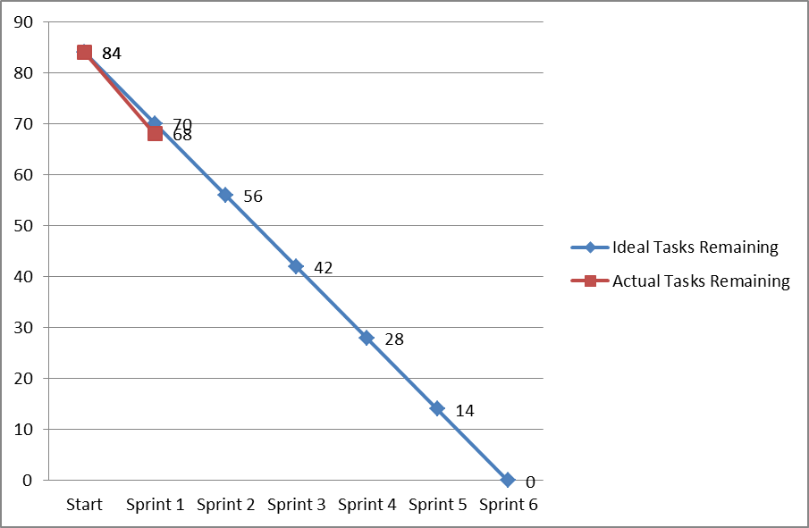

**Accuracy of Time Estimations:**

|  |  |  |
| --- | --- | --- |
| **Product Backlog Item** | **Estimated Completion Time** | **Actual Time Spent** |
| 1 | 16 hrs | 16 hrs |
|  |  |  |

**Note:** You should keep track of the time spent for tasks and compare them with your actual estimations, so that you can make a better estimation and update the product backlog before the next Sprint.